Setting up Postgresql JDBC Driver

*I use VS Code as my IDE, so all JAVA example images are for vs code. I use pgadmin 4 to access postgresql.

1. Download the driver from this [link](https://jdbc.postgresql.org/download/). Download the correct driver for the version of java you have installed, which is likely greater than java 8 so you can get the most recent driver. **Click the download button, not the copy maven**
2. Create a new JAVA project in your IDE of choice.
3. Move the JDBC driver you installed to your JAVA project directory, and set the classpath to reference this file. Reference images:

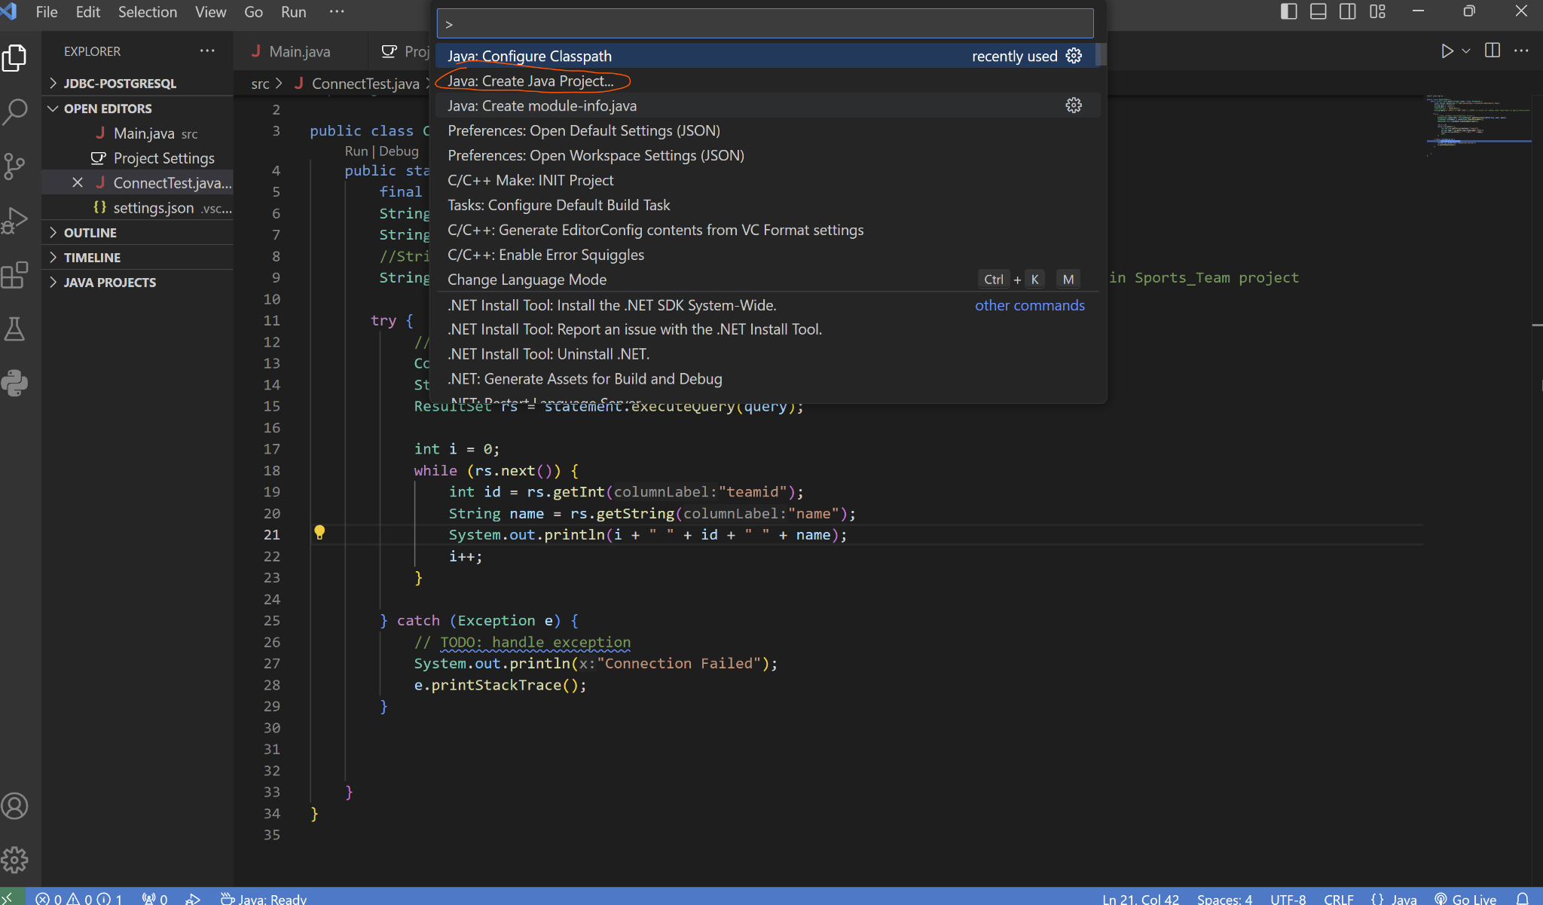

CTRL+SHIFT+P

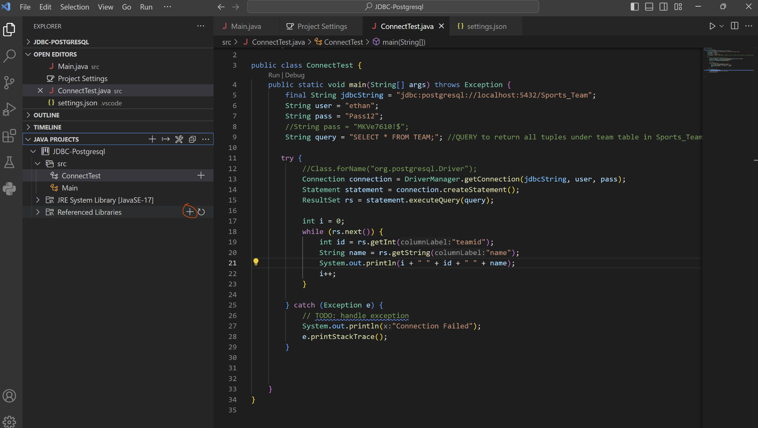

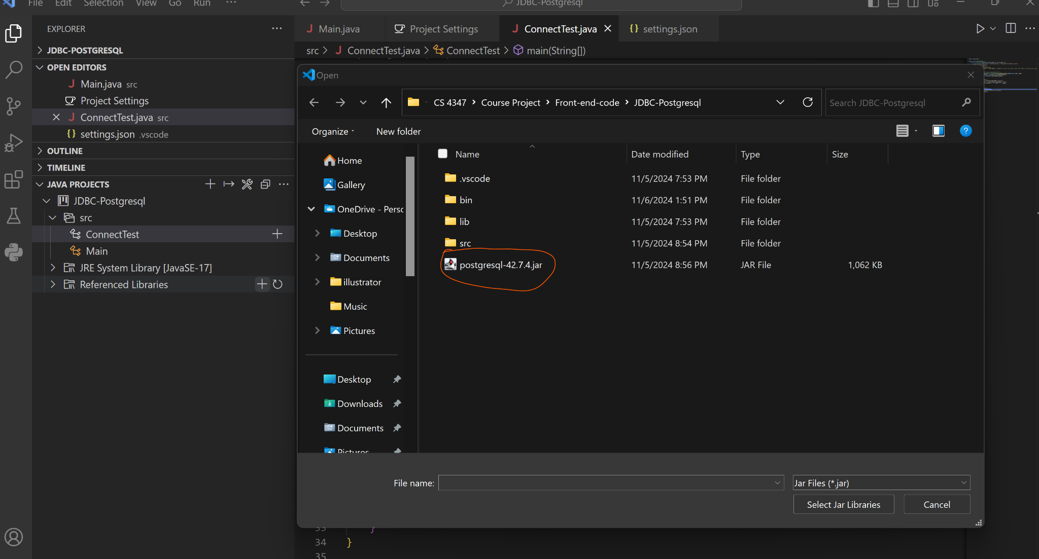

**\*If you do not use vs code, you will have to figure out where exactly the classpath properties are. Here is what the setting.json should look like though if you place the JAR in your java project directory.**

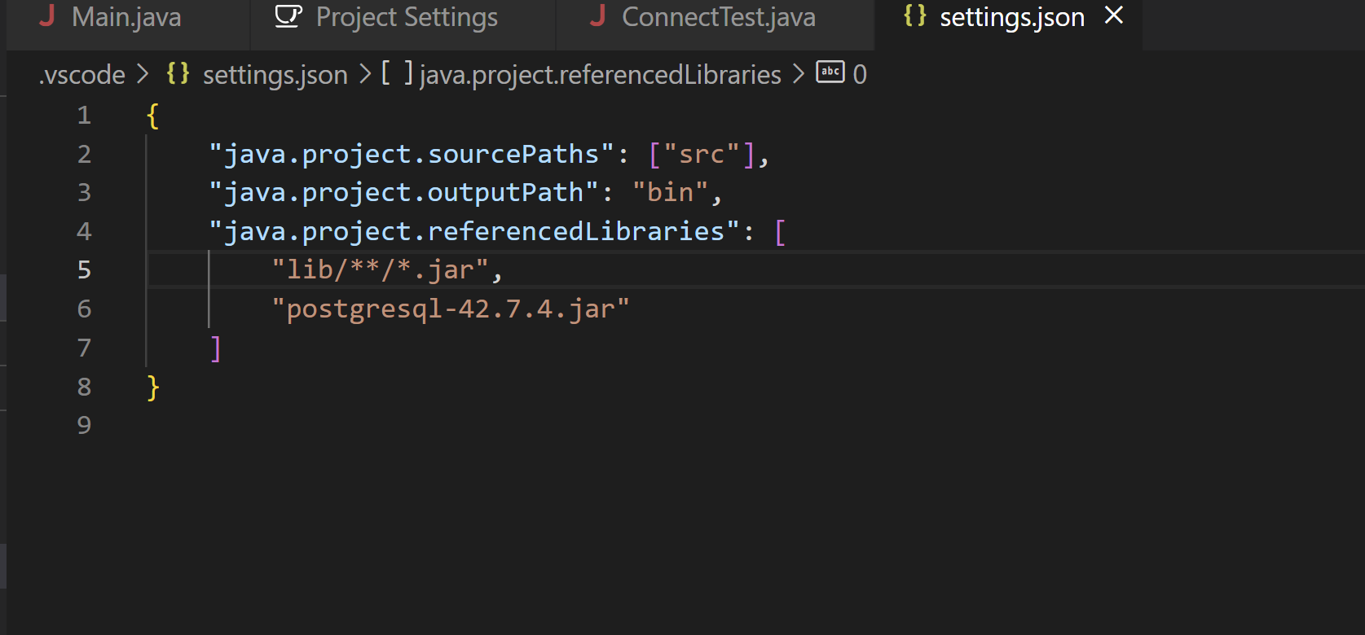

1. Create a user in postgresql using pgadmin4 or the command line. Reference images:

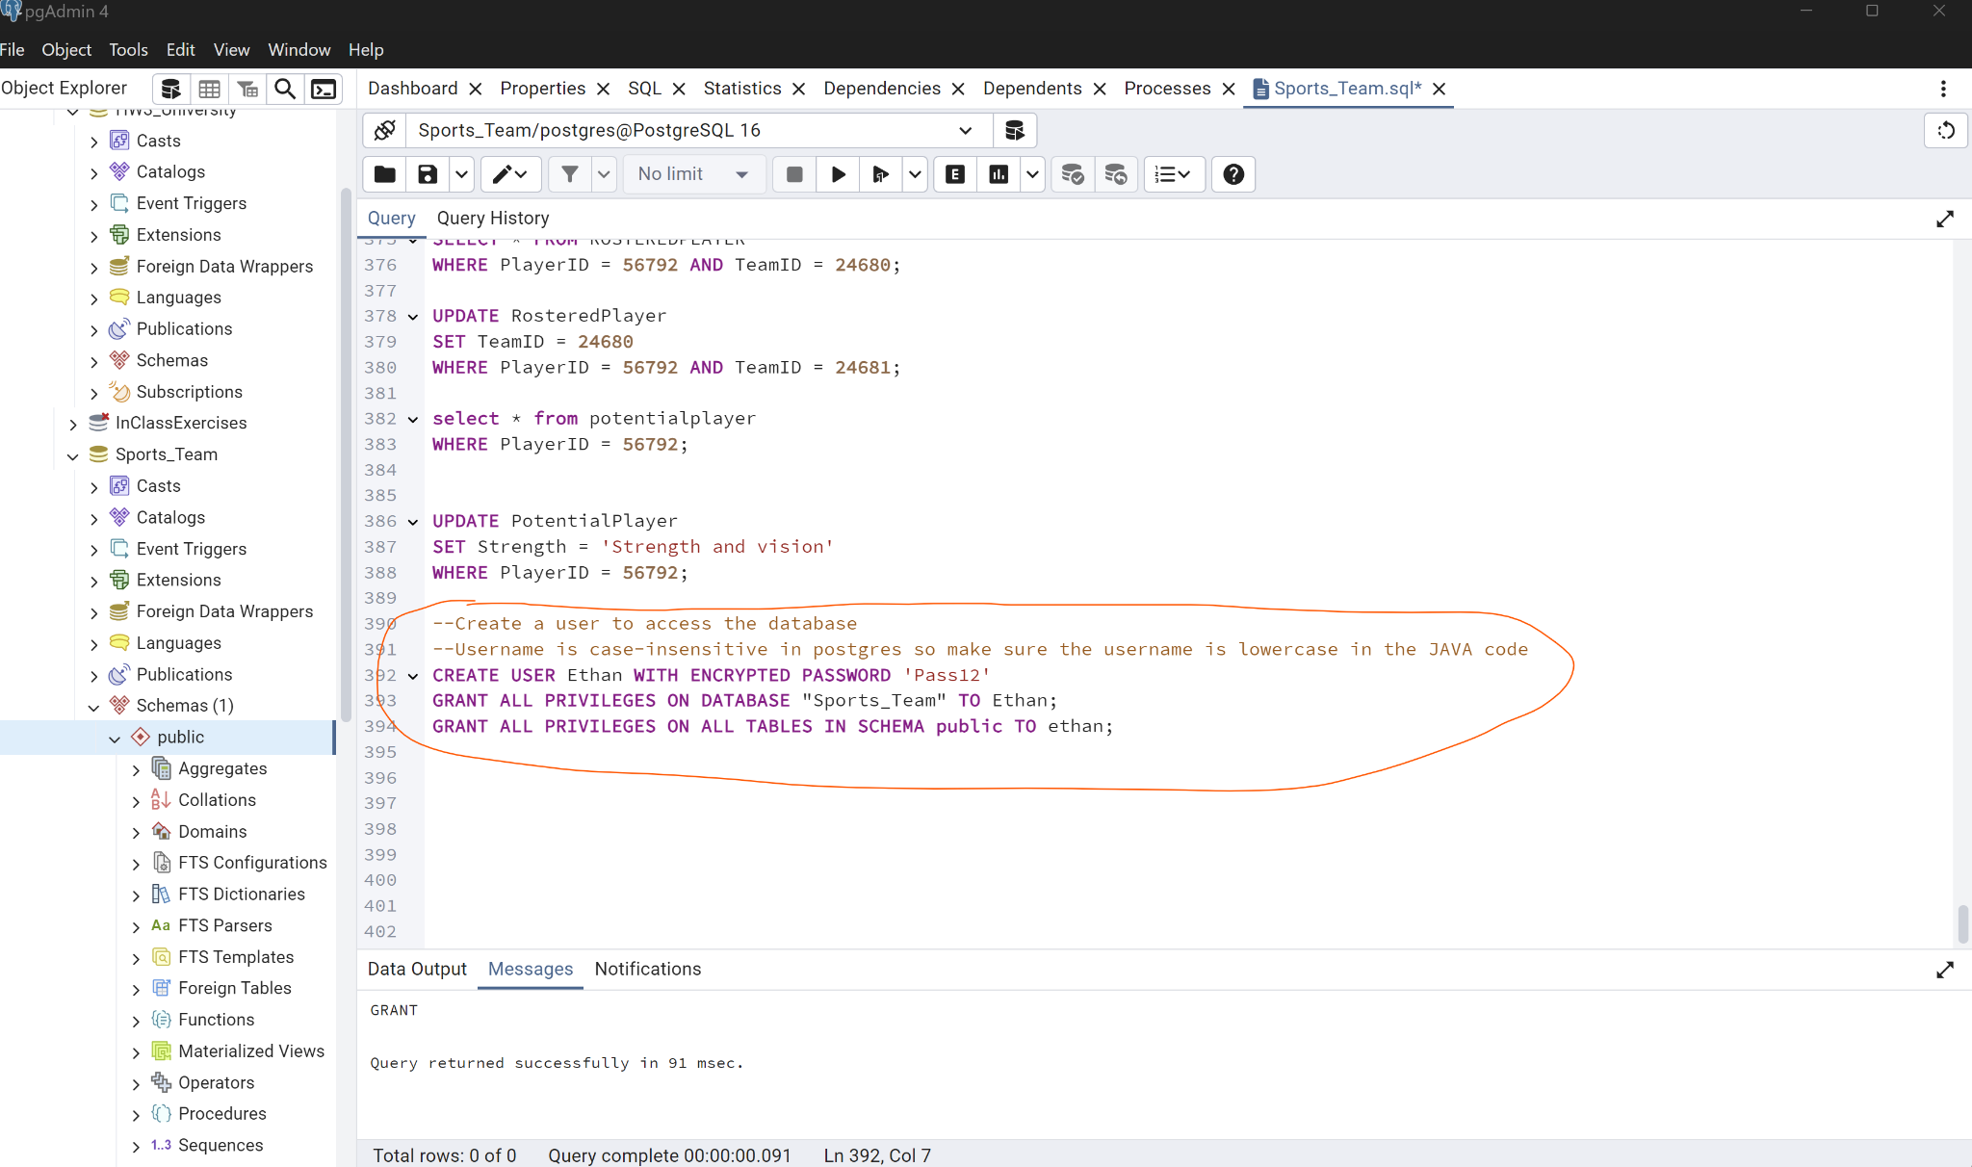

1. Download file **ConnectTest.java** from github and place it in your new JAVA project SRC directory.
2. Replace the underlined fields with the username, password, and port you created. You likely will also be using port 5432 if you did not explicitly change the port number.

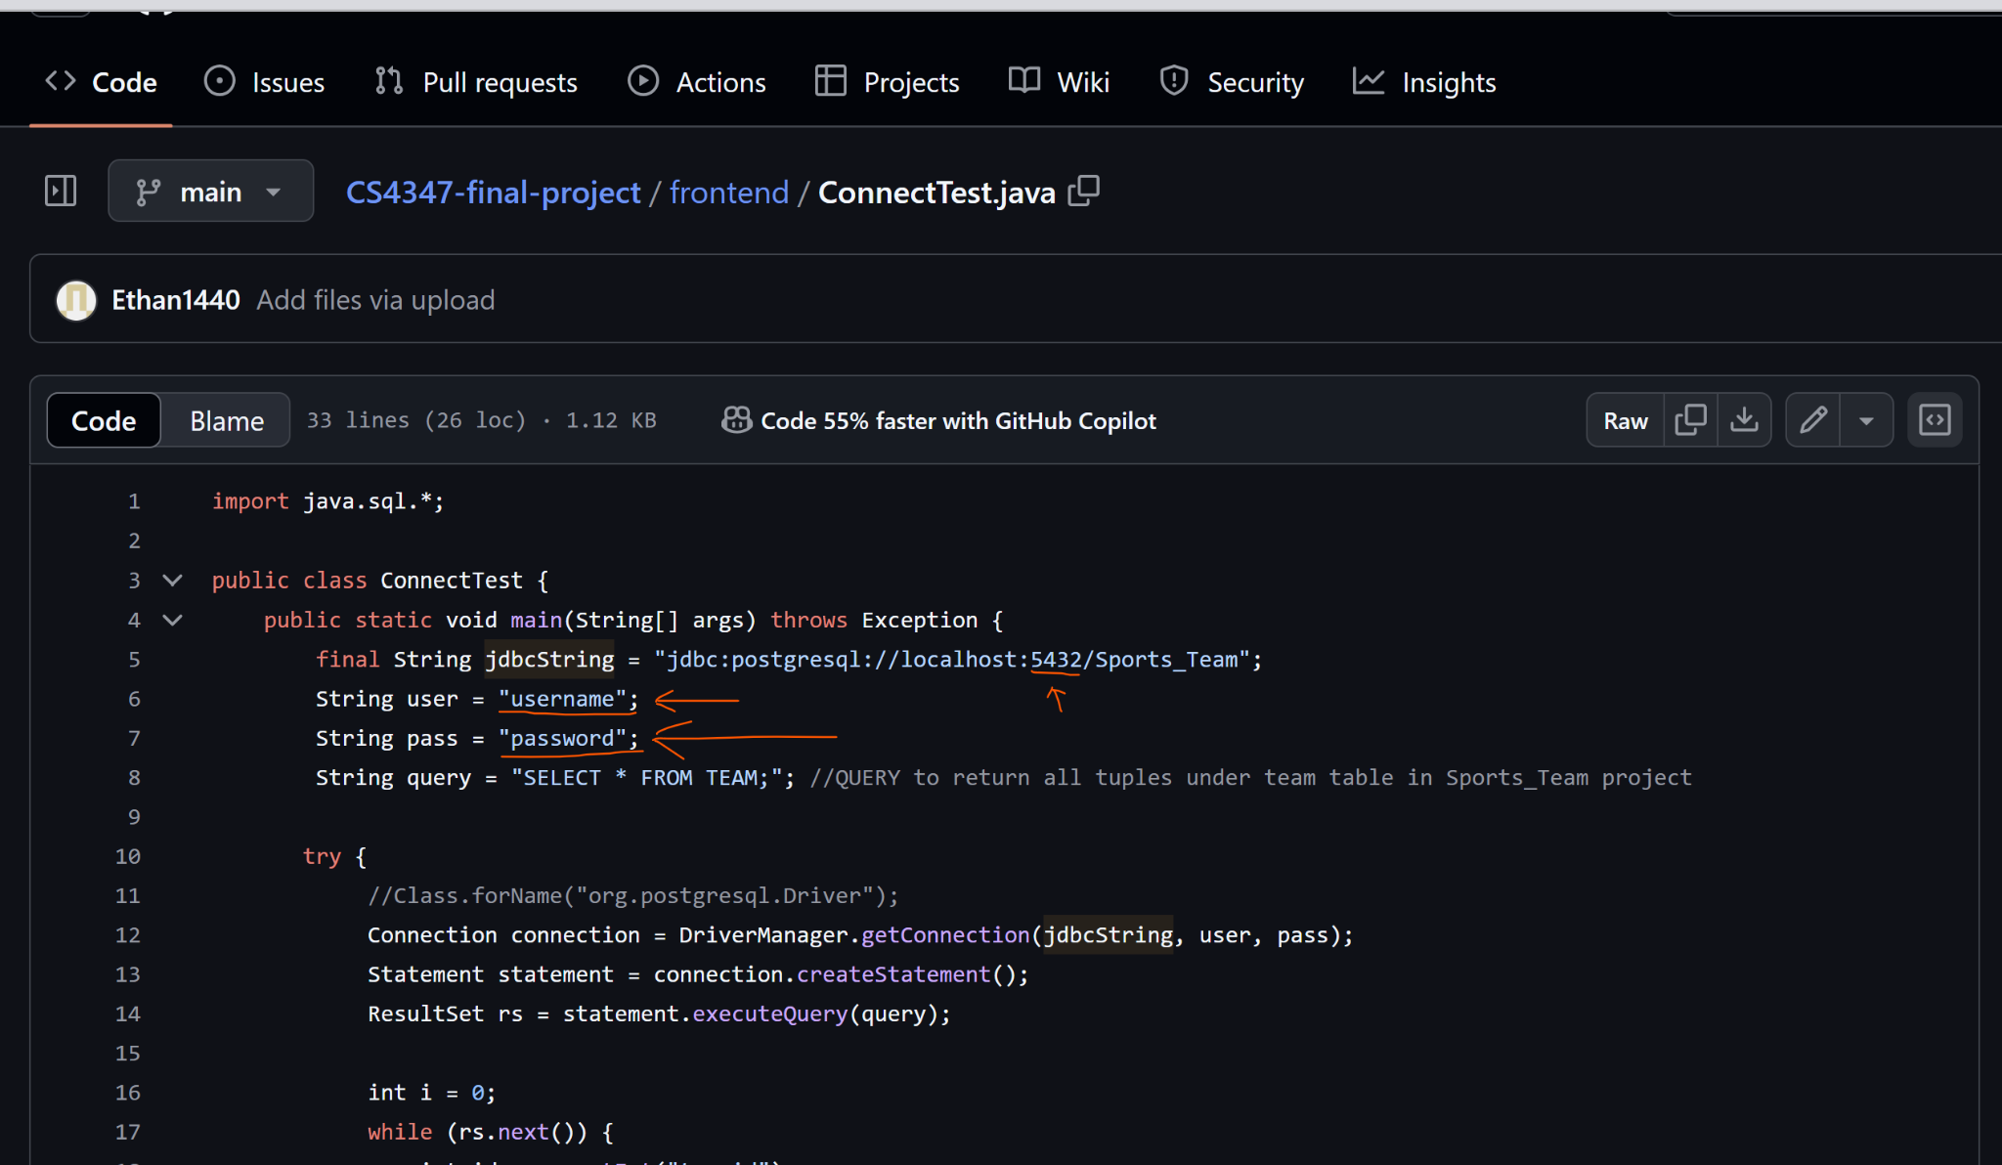

1. The code should now work if you click **Run Java**
2. Here is the output you should see if everything works.

